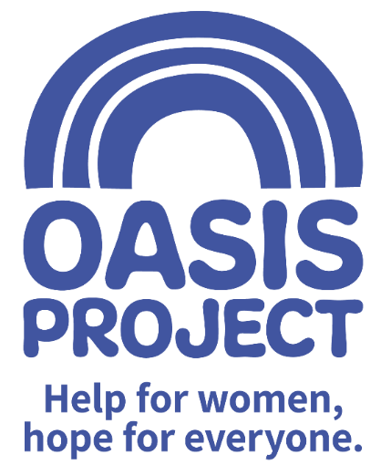

SWOP Practitioner (Project ADDER)*
Full time (37.5 hours per week) with option for 30 hours over 4 days on discussion

Hastings based, with some work delivered on outreach

Fixed term contract: 12 months

*This post is only open to female applicants as being female is deemed to be a genuine occupational requirement under Schedule 9, Paragraph 1 of the Equality Act 2010.

Salary £28,500 per year full time equivalent


Thank you for your interest in Oasis Project and our current vacancy.

This is your application pack. It will tell you about our activities and how you can apply for this role. After reading the pack we hope you will still be interested in applying and ask that you complete the application form and the equal opportunities monitoring form and return them both to us:

- by email to recruitment@oasisproject.org.uk
- by post to Globe House, 3 Morley Street, Brighton, BN2 9RA

The closing date is 9am on Friday 4 February 2022

Interviews will be held week Friday 11 February 2022, via an online process. The interview process will involve a series of competency based interview questions.

We hope the successful candidate will be able to start as soon as possible.

You will find the following enclosed within this pack:

- Introduction to Oasis Project

- Working at Oasis Project

- The recruitment process

  - Selection
  - Job description and person specification
  - Completing your application
  - Submitting your completed application
  - References, occupational health checks, UK work eligibility checks and DBS disclosure

Introduction to Oasis Project
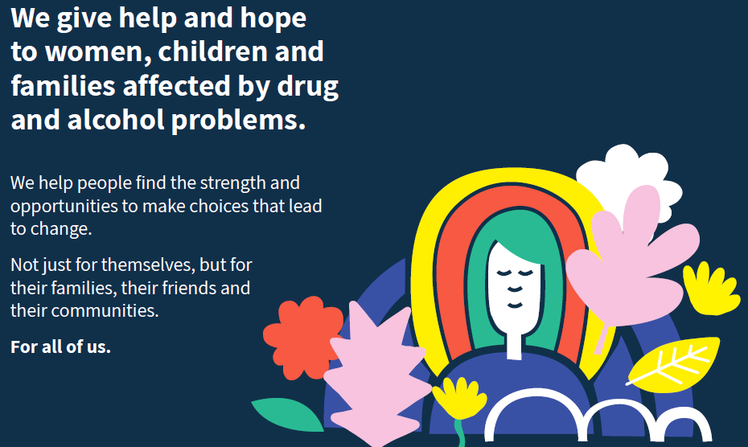

Working at Oasis Project:

Oasis Project aims to give help and hope to women, children and families in Brighton &Hove and across East Sussex affected by drug and alcohol problems.

We have been established since 1997 and take a gender-specific approach to service provision, working with all family members to achieve the best outcomes for our clients.

During 2019/2020 we worked with over 600 women and over 200 children from Brighton & Hove and across East Sussex, around 40 men and women with multiple and complex needs in Hastings and Eastbourne through Fulfilling Lives and around 30 fathers.

Our main services for adults in Brighton & Hove include:
- Open access (initial assessment for anyone referred or self-referring to Oasis)
- Parenting Our Children Addressing Risk (POCAR) - a psycho-social programme for parents who use drugs and/or alcohol and have social services involvement with their children – including a specialist programme for dads delivered from a separate premises
- Sex Workers’ Outreach Project (SWOP)
- Assessment and care co-ordination
- Structured group-work including Phase 2 for women seeking to take the next steps in their recovery
- Peer support

Our Young Oasis service includes:
- A therapeutic crèche for children aged 0-11 whose parents accessing treatment or support
- One to one therapy for children and young people 5-18 affected by substance misuse in the family
- A Young Women’s Therapy Service for women 18-25 who have experienced early trauma
- Mellow Parenting – an attachment based parenting programme for mums who have experienced problems with substances

East Sussex services:
- Groups and 1-1 keywork for women with a drug or alcohol problem
- Therapy for children and young people 5-18 affected by substance misuse in the family

Our Ethos

Our Core Truths
- Anybody can develop a problem with drink or drugs – whatever their background or situation.
- It is harder for women to escape drug and alcohol problems – they need specialist help.
- Drug and alcohol problems don’t just affect the individual – but everyone around them.
- Drink and drug problems aren’t just the cause of a difficult life, they’re a symptom of one.
- A bad start in life doesn’t have to mean a bad end.
- We’re not here to ‘fix’ anyone – we’re here to help women make choices that lead to change.
- We know that one size doesn’t fit all – we look at the individual

Our Values
Equality
We are a champion for equality, providing a non-judgemental service which respects the needs of its clients in all their diversity and recognises that one size does not fit all.

Accountability
We do what we say we are going to do and work with integrity, never losing sight of our responsibility for our actions

Caring
We deliver all our services with respect for individuals and our day to day interactions are characterised by compassion and kindness

Creativity
We use our unique insight and experience to problem solve, recognising the value of innovation when working with individuals and families

Collaboration
We work together with our clients, their families friends and networks and our professional partners to provide the best care possible, to keep people safe and to bring about positive change

Learning
We continue to develop and evolve our services to better meet the needs of our clients, facilitating involvement and feedback at every opportunity

All our values are underpinned by a seventh value, which is… Community

As a paid employee at Oasis, you will be expected to:

- Meet the skills and requirements as outlined in the job description and person specification for this role;

- Make sure that you can commit to the specific hours and days of work that the role requires;

- Make sure that you are able to travel to and from your respective project office. We have 2 offices in Brighton (11 Richmond Place, Brighton and at Globe House, 3 Morley Street, Brighton) and an office in Renaissance House, Hastings.

- Discuss and agree any support needed with your line manager or CEO of the project and/or the Human Resources Adviser.

- Engage with a culture of continuous professional development

- Observe the relevant requirements of all Oasis Project policies.

In return you can expect

Challenge and experience

The role of SWOP Practitioner within Project ADDER will be challenging but rewarding. It is a new role and you will have the opportunity to grow and develop the role, with the support of our experienced SWOP Manager, and the Oasis Women’s Recovery Service Manager who is based in Hastings.

Training and support

Oasis Project provides you with regular one to one sessions with your line manager and an annual appraisal to review progress and identify areas for development. Clinical supervision is also provided. We also strongly encourage continuous professional development and encourage learning from a range of different opportunities.

We like to develop talent and provide opportunities such as mentoring, shadowing, and secondments to ensure our employees continue to grow and learn and can remain motivated and passionate about their work.

Benefits
In return for your time and skills at work you will receive
- a fair salary, comparable with similar roles in the area.
- 28 days (210 hours) annual leave plus bank/public holidays pro rata (full time) or pro rata equivalent
- 1 hour away from work (paid) per month for well-being
- Training and learning opportunities
- Study leave for approved courses/training
- An employer contribution of 3% into our stakeholder pension scheme via Bluesky (on condition that you remain enrolled in the pension scheme and contribute a minimum of 5% of your salary).
- Free tea and coffee
- Occupational health – eye tests reimbursed; other health support provided as necessary.

A pay and reward review is also underway with the potential for an increased benefits package to be introduced later in the year.

Career and other benefits

Oasis Project aims to be an employer of choice. We are a professional, well-respected organisation and showing that you have been employed will provide great experience for you. We hold the Investors in People external accreditation and in November 2021 were nominated in the National “Third Sector Award” category of which there were only a handful of nominees from across the country.

THE RECRUITMENT PROCESS
At Oasis Project we are committed to providing the best possible recruitment service including working to remove barriers to equal opportunity at each stage of the recruitment process. Our commitment to you is that:
- We will treat you in a polite, helpful and friendly manner at all times.
- Information that you provide will be treated as confidential and will be seen only by those involved in the recruitment process.

- We will remove all personal information from your application to ensure that the short listing panel are not aware of whose application they are assessing. All staff will have undergone recent unconscious bias training.

- We will ask you to complete an equal opportunities questionnaire – this information is only used for monitoring purposes.

- We will endeavour to make any reasonable adjustments to the selection process (application form, interview or training) to enable individuals to participate equally

- If you are selected to progress to the next stage you will be advised as soon as possible.

- We will aim to give you at least one week’s notice prior to interview, or we will make it clear in the job advertisement when the interviews will be held.

- We will not contact your referees unless you give your permission. We will however need to obtain two satisfactory references as a condition of any employment offer.

- A decision will be made as soon as possible after interviews and you will be informed, normally within 1 week.

- Unsuccessful interviewees will be offered feedback.

Selection
Step 1: The first step is to fill in an application form before the closing date. Once you’ve submitted your application form, we will assess whether or not you have demonstrated that you meet the criteria detailed on the person specification for the role.

Step 2: If you are shortlisted at the application stage, the second step will be that you are invited to attend an interview where we will assess whether you’re suitable for the role. You will be sent an interview invitation via email or letter. At the interview you will need to demonstrate that you can meet the criteria in the person specification.

Step 3: If you’re selected, the third step is that you will undertake a thorough induction and complete the mandatory training programme.

Completing your application
You will need to download an application form. You can download this from the same page where you accessed this recruitment information pack. You can find information about all Oasis’ vacancies here: http://www.oasisproject.org.uk/job-vacancies/

You may submit either a typed or hand-written application and send this via email or in the post. If you decide to hand-write your application please ensures that it is legible. Please ensure that your personal information is completed including a contact telephone number if possible.
Please note that we do not accept CVs.

In your application you will need to demonstrate that you have the skills to meet the requirements of the role. Please read the job description and person specification carefully and address your supporting statement to the stated criteria.

It is important to complete the Equal Opportunities Monitoring form and return it with your completed application as this helps us to monitor our recruitment process and ensure that we are attracting a diverse range of people to want to work and volunteer at Oasis.
Submitting your application

By email: Please email your completed application form and equal opportunity form to recruitment@oasisproject.org.uk

By post: Please send your completed application form and equal opportunity form to: Administration Manager, Globe House, 3 Morley Street, Brighton, BN2 9RA

Methods of assessment
A range of methods, (although the same for each person) will be used to assess each application that is received for the role. These will include:
- Application form and supporting statement
- Checking qualifications against certificates / registrations with professional bodies
- Interview
- Possible test (such as typing test, report writing, data entry, presentation). You will be informed in advance if a test will be used during an interview process.
- References

Recruitment checks:
References
We require two references. They will not be contacted without your permission but we will
need to obtain two satisfactory references before you can take up any employment offered
to you. If you can provide an email address for your referees this is helpful.

Eligibility to work in the UK
We require you to provide appropriate ID documentation that proves your eligibility to work
in the UK.

Occupational health check
You will be asked to complete an online medical questionnaire, via our occupational health
providers. Our occupational health experts will confirm to Oasis Project whether you are fit
(or not fit) to undertake the role, or if adjustments may be required, based on the
information that you have disclosed.

Ex-offenders / Disclosure and Barring Service (DBS) Checks
All applicants are required to disclose details of any unspent convictions in accordance
with the Rehabilitation of Offenders Act 1974. Any disclosure of an unspent conviction will
NOT automatically disqualify your application unless the nature of the offence renders you
unsuitable for the role. All such disclosures will be considered on an individual basis.
There is space on the application form for this information.

If your employment at Oasis will include working with children and vulnerable adults you
will be required to undertake a DBS check (with the costs for this being met by Oasis).

We wish you success with your application.

